blazer with bunk design – Gray
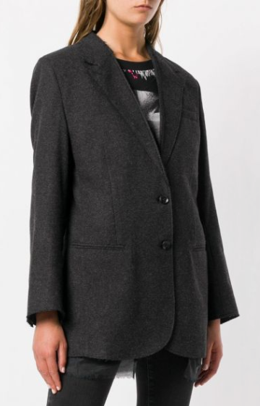
$500

Diesel wool and silk-blend blazer in a Diesel layered design with notched lapels, buttonhole on the front, long sleeves, buttoned cuffs, front welt pockets, full lining, relaxed fit, raw edges and a back slit.

